App in a Day

Hands-on Lab Step-by-Step

Contents

Importing Module 1 Completed 1

Task 1: Create a new environment 1

Task 2: Import the solution 2

# Importing Module 1 Completed

Follow the steps below, if you did not complete Module 1 and would like to skip to Module 2

## Task 1: Create a new environment

1. Open a new browser tab, navigate to [Power Apps admin portal](https://admin.powerplatform.microsoft.com/) select **Environments** and click **New Environment**.

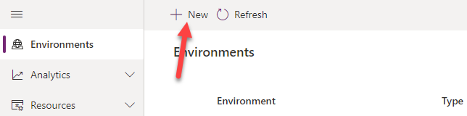

1. Provide an **Environment Name**, select **Trial** for **Type**, select **Region**, select **Yes**, for **Create** a database for this environment, and click **Next**.

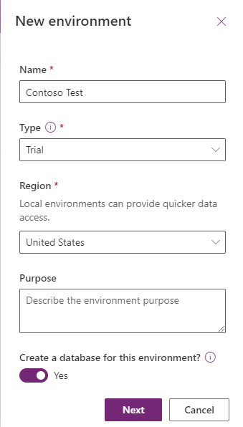

1. Select **Language, URL**, and **Currency**. Click **Yes** for **Deploy sample apps** **and data** and then click **Save**.

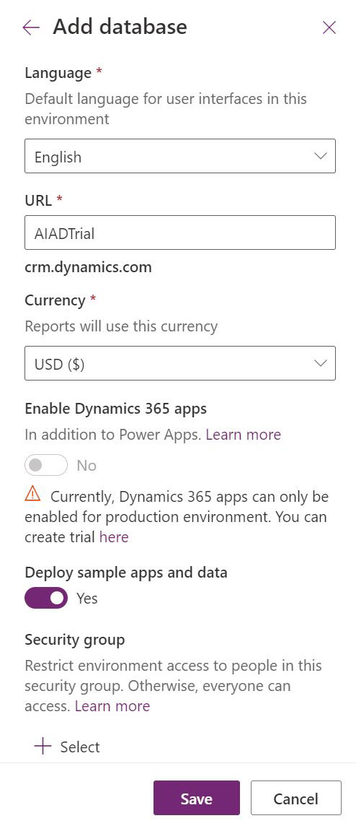

1. Wait for the environment to be created.

## Task 2: Import the solution

In this task, you will import the completed module 1 solution.

1. Navigate to [Power Apps maker portal](https://make.powerapps.com/)
2. Make sure you are in the **Contoso Test** Environment you created.
3. Select **Solutions** and click **Import**.

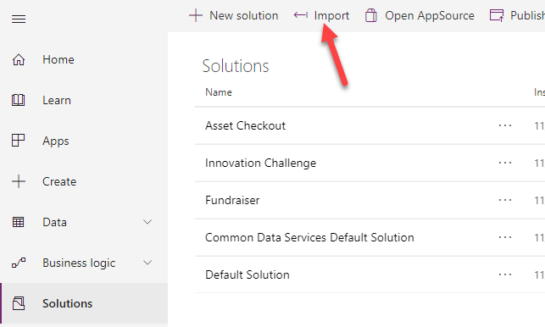

1. Click **Browse**.

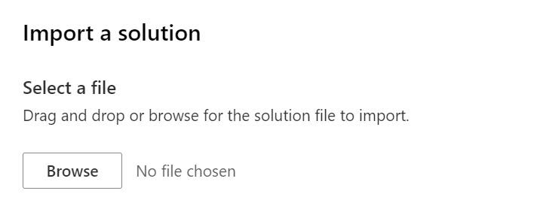

1. Select the **Contoso Coffee** solution zip file located in Module 1 Completed folder and click **Open**.
2. Click **Next**.
3. Click **Import**.

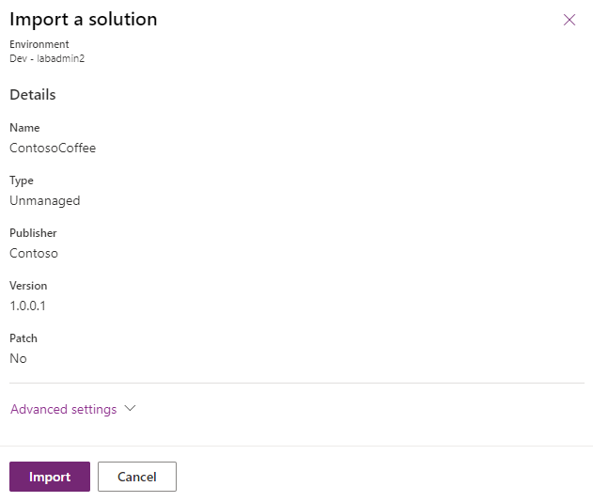

1. Wait for the solution import to complete.

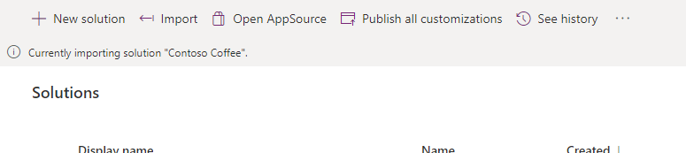

1. Click **Publish all customizations** and wait for the publishing to complete.

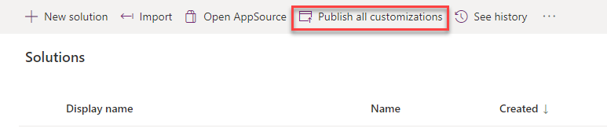

1. Click **Apps**, click on the **…** button of the **Machine Ordering App** and click **Play**.

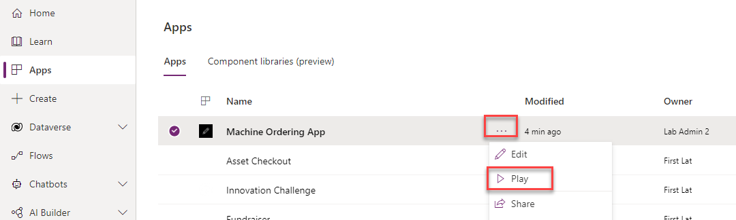

1. Confirm the application loads.

